 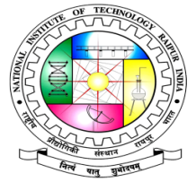

**EVENT REPORT**

**PUKAAR 2020**

**Date of Event: 25 January, 2020**

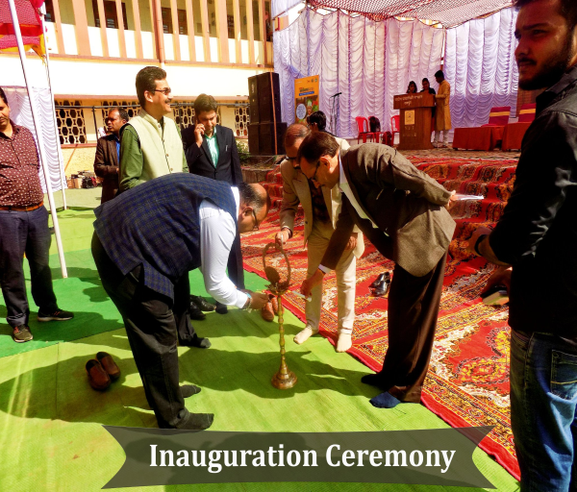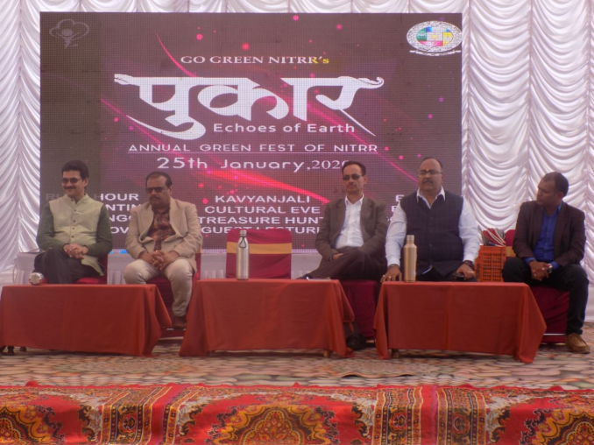

The Go Green Committee, NIT Raipur started off the year on a high note with its eco fest Pukaar. The sole objective of this event since its inception has been to keep the human and nature bond intact through its events. With a steadily growing audience each year, the 3rd edition of this annual occasion attracted a vigorous participation from the students.The chief guests of the event were Mr Vishwesh Kumar Rao, Deputy CEO, CAMPA, CG Forest Department; Mr A.P. Sawant, Public Relations Officer, CECB; Mr Dinesh Awasthi, Superintendent Engineer, CREDA. The main venue for the occasion was the Cycle Stand where the event was inaugurated by the chief guests along with Dr Sameer Bajpai and Dr D.C. Jhariya, Go Green faculty in charge.The inauguration ceremony was followed by the Eco Innovation project exhibition which was later followed by the Green Exhibition, eco quiz, tree hunt and many more events throughout the daytime.

The event wise description of the occasion have been mentioned below.

**1.Eco Innovation**

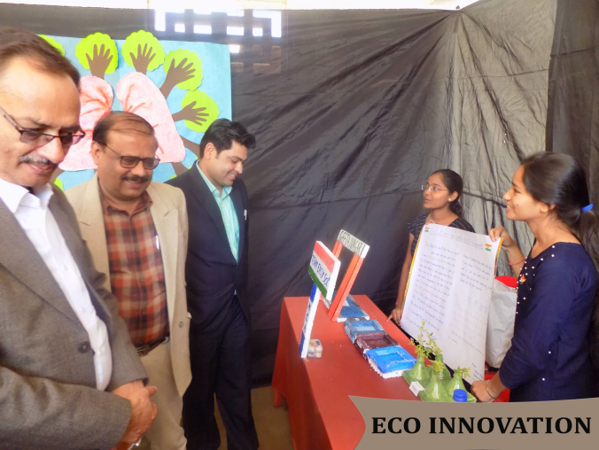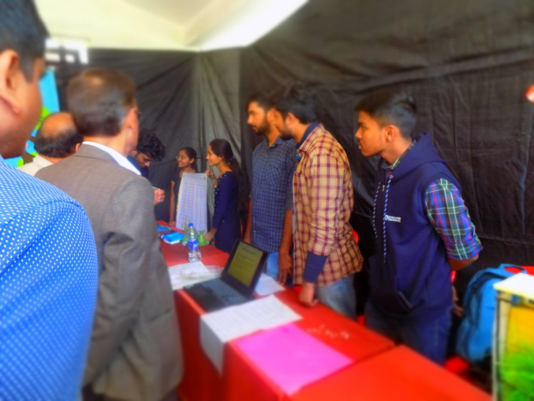

An environment centred project exhibition that showcased various modelled solutions to current environment related problems.

**2.Green Exhibition**

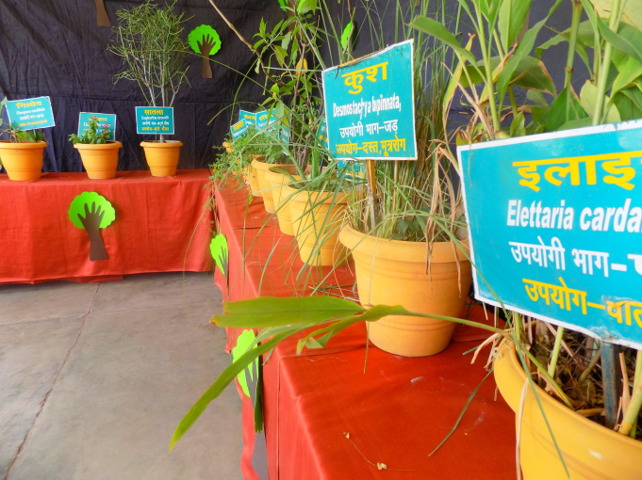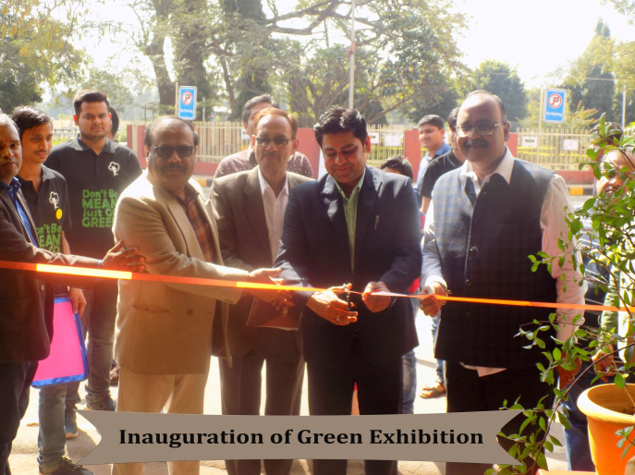

An event where various useful indigeneous herbs and plants along with their benefits were showcased to increase knowledge of.these plants among students.

**3. Eco Quiz**

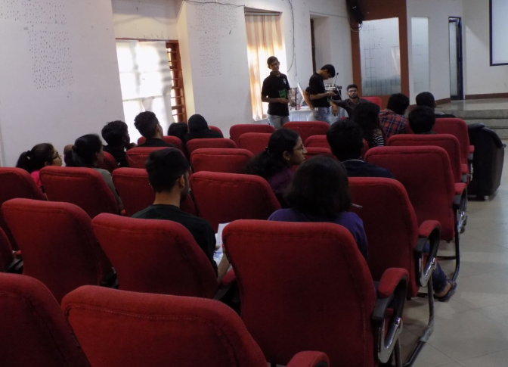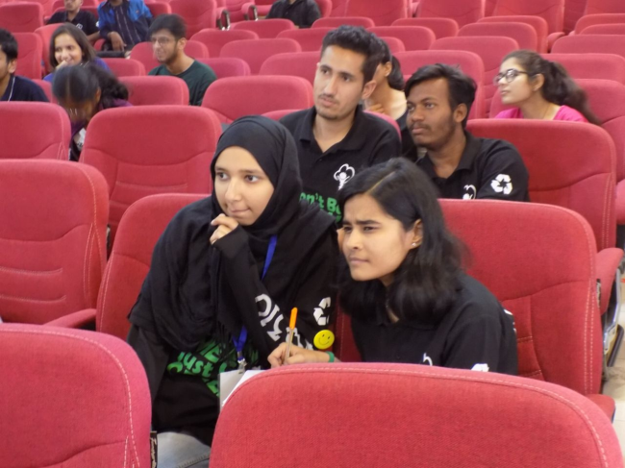

Environment trivia quiz where participants put their environment knowledge to test. An approximate total of 50 participants tried their intelligence and environment awareness in this contest.

**4. Tree Hunt**

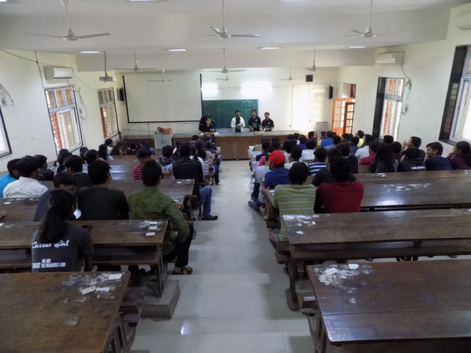 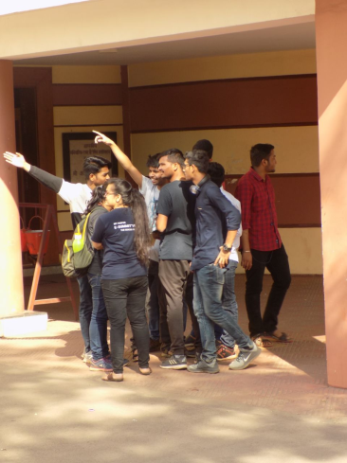

A treasure hunt based on tree and location characterized clues that led to specific trees at landmarks present inside the institute perimeter .Many as 25 teams tested their riddle solving abilities in the contest with 2 teams finally making it to the top.

**5. Rangoli Making**

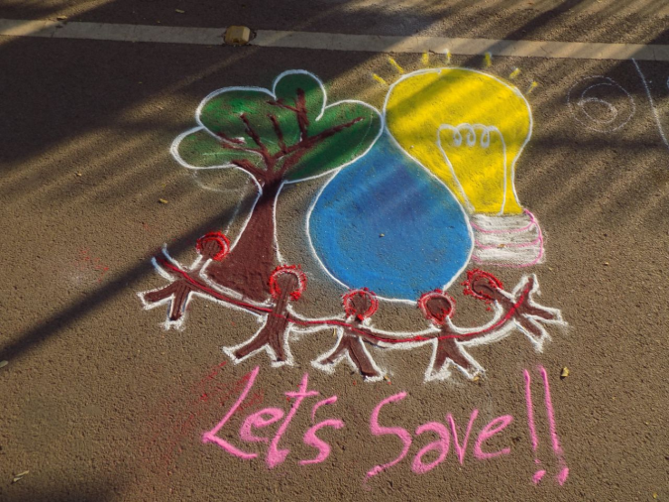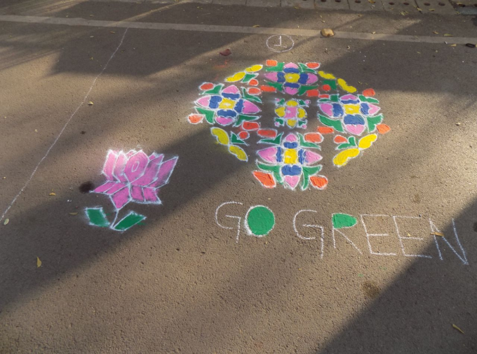

A colorful competition where participants showcased their rangoli making talents clubbed with environmental message.

**6. Pot Painting**

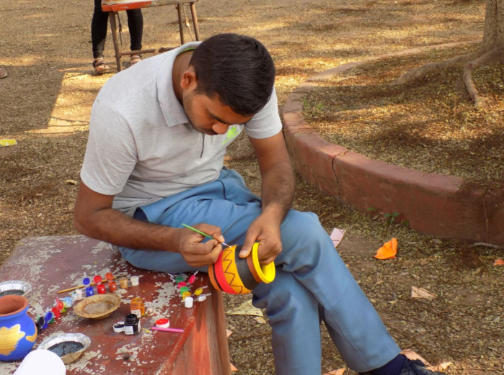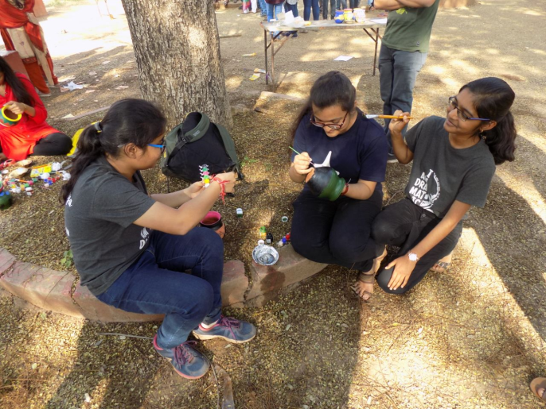

Participants unleashed their imagination and let their creativity do the rest on the walls of earthen pots.

**7. Slow Cycle Race**

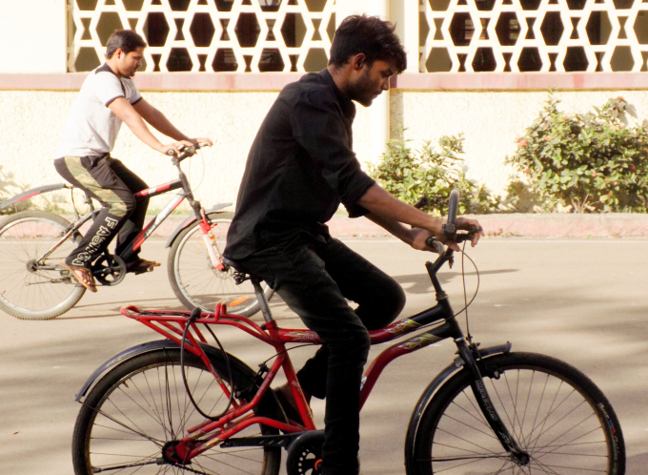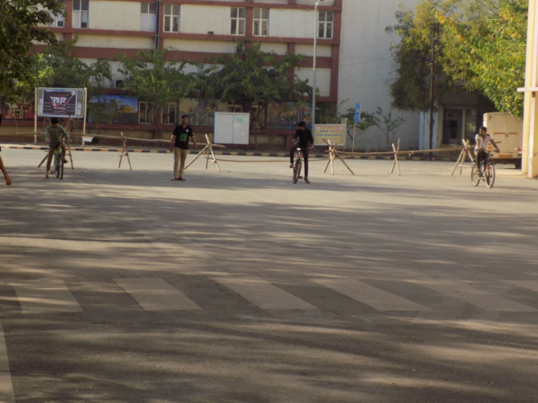

A fun event where slowness and steadiness of participants on pedals were the decider.

**8.Rush Hour**

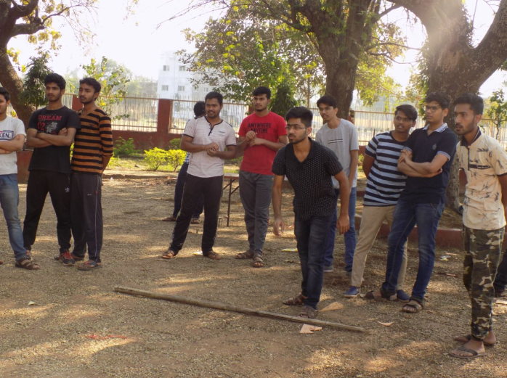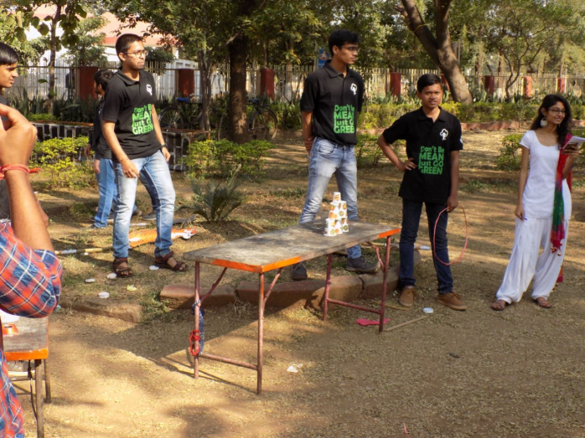

A fun filled event where speed and presence of mind were the key to get through different games.

**9.Honour the Heroes**

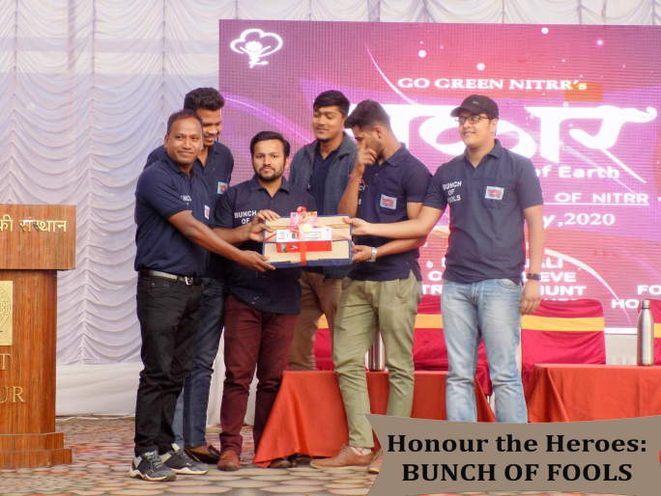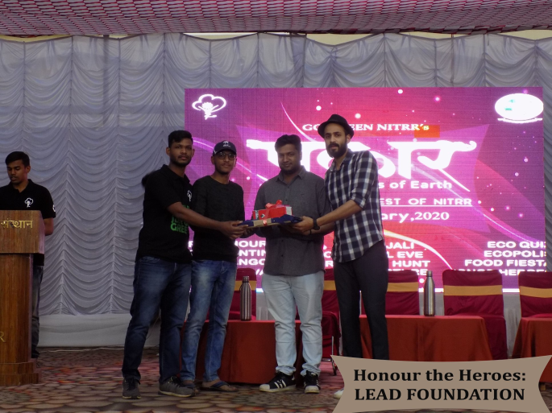

Every act towards environment conservation should never go in vain and appreciation of such initiatives ensures that their stories are farfetched among masses. Many such efforts like Bunch of Fools , Lead Foundation and Nova Nature Club were honored for their work for such noble purpose.